SIMATS ENGINEERING
ASSESSMENT TOOL 2: Scenario-Based Questions
COURSE NAME: COMPUTER VISION
COURSE CODE:ITA0501

COURSE OUTCOME COVERED
CO2: Apply image enhancement and segmentation techniques for extracting meaningful regions from images. (BTL 3)

QUESTIONS: 5 Duration :60 Minutes

Max Marks50
Annexure A
Scenario-Based Questions

Code of Conduct:
I __K.Varshini/192472358___ (Name / Reg No) certify that this submission is my original work and that I have adhered to the guidelines specified for this assessment.I understand that any violation of academic integrity rules will result in disciplinary action.
Signature of the student:K.varshini

Question 1: Dental X-Ray Enhancement and Cavity Region Extraction

1.1 Understanding of the Scenario
A dental clinic uses digital radiography to detect early-stage caries (cavities). A cavity is a region where the mineral content of enamel or dentine has been lost. Because X-rays are attenuated less by demineralised tissue, a cavity appears as a slightly darker patch inside a brighter tooth. In early stages the difference is only a few grey levels, so the cavity almost merges with its surroundings.
The images supplied to us have four properties that make automatic analysis hard:
- They are dark and low in contrast, so the histogram is squeezed into a narrow band at the low end of the grey scale.
- They contain quantum (photon) noise, which is signal dependent and appears as a grainy texture.
- Overlapping structures (neighbouring teeth, bone, fillings) superimpose on each other, producing false edges and intensity gradients.
- Early cavities are small, so any smoothing that is too strong will erase them.
The goal is therefore a chain of operations that (1) stretches contrast, (2) removes noise without moving the cavity boundary, (3) isolates the suspicious region and (4) draws its outline so that a dentist can inspect it.

1.2 Key Issues Identified
No. | Issue in the image | Consequence | Technique chosen to handle it
1 | Overall darkness (histogram concentrated at low grey levels) | Small intensity differences are invisible | Power-law (gamma) transformation with gamma < 1
2 | Low local contrast between cavity and enamel/dentine | Cavity merges with tooth | Histogram equalization, preferably contrast-limited (CLAHE)
3 | Quantum noise | Spurious bright and dark pixels; false edges | Median or bilateral filter
4 | Need to preserve cavity boundary | Strong blurring destroys small lesions | Edge-preserving smoothing, small kernel
5 | Need to isolate the lesion | Dentist needs a region, not a picture | Otsu / adaptive thresholding, region growing
6 | Need a visible outline | Overlay on original X-ray | Canny edge detection on the cleaned mask

1.3 Overall Processing Pipeline
The order of operations matters. The pipeline used is:
- Acquisition and normalisation of the X-ray to 8-bit grey scale.
- Grey-level transformation (power-law, with log and negative considered) to brighten dark regions.
- Histogram equalization (global, then CLAHE) to spread the grey levels.
- Spatial smoothing (median filter, optionally followed by a light Gaussian or bilateral filter) to suppress noise.
- Segmentation by thresholding and region growing to obtain the suspected cavity region.
- Morphological clean-up of the binary mask.
- Edge detection (Canny) on the mask or on the smoothed image to outline the cavity.
- Overlay of the outline on the original image and quantitative evaluation.
A short summary of the logic: first make the information visible (steps 2-3), then make it reliable (step 4), then extract it (steps 5-6), then present it (steps 7-8). Noise removal comes after contrast enhancement in this answer for a specific reason explained in section 1.11.

1.4 Step 1: Acquisition and Normalisation
Digital radiographs are often stored at 12 or 16 bits. They are first rescaled to 8 bits (0 to 255) so that the classical operators below can be applied. If the image has a bright border or a text label, a region of interest (ROI) around the teeth is cropped so that the empty background does not distort the histogram. This matters because histogram-based methods (equalization, Otsu) treat every pixel equally, and a large black collimator border would dominate the histogram.

1.5 Step 2: Grey-Level Transformations
A grey-level (point) transformation changes each pixel independently using s = T(r). It is cheap and gives immediate control over brightness and contrast.

1.5.1 Image negative
s = (L - 1) - r = 255 - r
The negative reverses the scale so that dark details on a bright background become bright details on a dark background. It is useful when the lesion is darker than its surroundings and the observer is more sensitive to bright structures on a dark field, which is the way many radiologists read dental films. The negative does not change the information content, so it is a display choice, not an enhancement of contrast.

1.5.2 Log transformation
s = c log(1 + r), with c = 255 / log(1 + 255) = 255 / 5.545 = 45.99
The log curve expands the dark grey levels and compresses the bright ones. Worked values (natural log):
Input r | log(1 + r) | Output s = 45.99 x log(1 + r)
10 | 2.398 | 110
50 | 3.932 | 181
100 | 4.615 | 212
200 | 5.303 | 244
An input range of 0-10 is stretched to 0-110, so very dark detail becomes visible. The disadvantage is that the compression of bright levels is strong, and bright enamel can lose its internal texture. The log transform is therefore best when the image is extremely dark (for example a poorly exposed film).

1.5.3 Power-law (gamma) transformation
s = c r^gamma, with r normalised to the range [0, 1]
The exponent gamma controls the curve: gamma < 1 brightens (like log but gentler), gamma = 1 is the identity and gamma > 1 darkens. Worked values with c = 1 and gamma = 0.5:
Normalised r | s = r^0.5 | Output on 0-255 scale
0.04 | 0.20 | 51
0.10 | 0.316 | 81
0.25 | 0.50 | 128
0.64 | 0.80 | 204
1.00 | 1.00 | 255
The dark range 0 to 0.25 is expanded to 0 to 0.5, so half of the output range now represents the darkest quarter of the input, which is exactly where the cavity information lies.

1.6 Step 3: Histogram Equalization
Gamma correction shifts the histogram but does not guarantee that the available grey levels are used efficiently. Histogram equalization (HE) remaps grey levels using the cumulative distribution function (CDF):
s_k = (L - 1) x sum of p(r_j) for j = 0 to k
The mapping spreads frequently occurring grey levels apart, which raises contrast in the densest part of the histogram.

1.6.1 Worked example
Consider a 3-bit image (L = 8) with 64 pixels and a dark histogram.
r_k | n_k | p(r_k) | CDF | s = round(7 x CDF)
0 | 15 | 0.234 | 0.234 | 2
1 | 20 | 0.313 | 0.547 | 4
2 | 12 | 0.188 | 0.734 | 5
3 | 8 | 0.125 | 0.859 | 6
4 | 5 | 0.078 | 0.938 | 7
5 | 3 | 0.047 | 0.984 | 7
6 | 1 | 0.016 | 1.000 | 7
7 | 0 | 0.000 | 1.000 | 7
After mapping, the new histogram has 15 pixels at level 2, 20 at level 4, 12 at level 5, 8 at level 6 and 9 at level 7 (the sum is 64). The dominant dark levels 0 and 1 have moved apart from level 0-1 (gap of 1) to level 2-4 (gap of 2), and the output now reaches level 7. The few bright levels were merged, which shows the known drawback of HE: sparsely populated levels are lost.

1.7 Step 4: Spatial Smoothing for Noise Suppression
Quantum noise follows approximately Poisson statistics: the variance grows with the signal. After enhancement it appears as grain with isolated bright and dark pixels. A spatial filter replaces each pixel by a function of its neighbourhood.

Candidate filters
Filter | Operation | Effect on noise | Effect on edges | Verdict
Mean (box) filter | Average of the window | Reduces Gaussian noise | Blurs edges strongly | Rejected
Gaussian filter | Weighted average, weights fall off with distance | Reduces noise smoothly | Blurs edges, less than the box filter | Acceptable for light smoothing
Median filter | Median of the window | Excellent for impulsive (salt-and-pepper-like) noise | Preserves edges and small steps | Selected
Bilateral filter | Weights depend on distance and intensity difference | Good | Preserves edges very well | Good alternative, costlier
Anisotropic diffusion | Smooths along edges, not across | Very good | Excellent | Useful but iterative and slower

1.8 Step 5: Segmentation of the Suspected Cavity Region

1.8.1 Thresholding
Thresholding creates a binary image:
g(x, y) = 1 if f(x, y) < T, otherwise 0 (cavity darker than the tooth)
Global thresholding with Otsu's method chooses T that maximises the between-class variance:
sigma_B^2(T) = w0(T) w1(T) [mu0(T) - mu1(T)]^2
where w0, w1 are the proportions of pixels below and above T and mu0, mu1 their mean intensities. Otsu works well when the histogram is bimodal. A whole dental image contains many classes (background, bone, enamel, dentine, pulp, filling), so a single global T will not isolate the cavity. The practical solution is a two-stage threshold:
- Apply Otsu to the tooth ROI to separate tooth from background and bone.
- Inside the tooth mask, apply a local (adaptive) threshold: T(x, y) = mean in a 31 x 31 window minus a constant C (about 5 to 10). Pixels clearly darker than their local neighbourhood are marked as cavity candidates.
Adaptive thresholding is required because brightness varies from the crown to the root and between overlapping teeth.

1.8.2 Region growing
Thresholding ignores spatial connectivity, so it may mark isolated noisy pixels or produce a fragmented lesion. Region growing uses the pixel position as well:
- Seed selection. Seeds are taken from the darkest connected pixels inside the tooth that survive thresholding (or are clicked by the dentist).
- Similarity criterion. A neighbouring pixel joins the region if |f(neighbour) - mean of region| < delta, with delta about 10 to 15 grey levels. A criterion based on the running region mean prevents slow drift.
- Connectivity. 8-connectivity is used so that diagonal growth is permitted.
- Stopping rule. Growth stops when no neighbour satisfies the criterion, or when the region area exceeds a clinically plausible limit.
Region growing gives one connected, compact region per seed, which is the shape of a real cavity. Its drawbacks are sensitivity to the seed and to delta; they are reduced by the earlier enhancement and smoothing.

1.8.3 Choice
Thresholding is used as the automatic first pass to find candidate seeds, and region growing is used to finish the region. This combination avoids the fragmentation of pure thresholding and the seed dependence of pure region growing.

1.8.4 Morphological clean-up
The binary mask is cleaned by opening (erosion then dilation) with a 3 x 3 structuring element to remove isolated pixels, followed by closing to fill small holes inside the lesion. Connected components with area below a minimum (for example 20 pixels) are deleted.

1.9 Step 6: Edge Detection to Outline the Cavity
Edge detection finds places where intensity changes sharply, which are the boundaries of the extracted region.
Operator | Principle | Remark
Sobel | First derivative with built-in smoothing (3 x 3) | Simple, noise tolerant, thick edges
Prewitt | First derivative, uniform weights | More sensitive to noise than Sobel
Laplacian | Second derivative | Very noise sensitive, no direction
Laplacian of Gaussian (LoG) | Gaussian smoothing then Laplacian | Zero crossings give closed contours
Canny | Gaussian, gradient, non-maximum suppression, hysteresis | Thin, well localised, continuous edges
The Sobel kernels are Gx = [-1 0 1; -2 0 2; -1 0 1] and Gy = [-1 -2 -1; 0 0 0; 1 2 1]. The gradient magnitude is |grad f| = sqrt(Gx^2 + Gy^2) and the direction is atan2(Gy, Gx).
Canny edge detector (selected). The steps are:
- Smooth with a Gaussian (sigma about 1.0 to 1.4).
- Compute gradient magnitude and direction.
- Non-maximum suppression: keep a pixel only if its magnitude is a local maximum along the gradient direction, giving one-pixel-wide edges.
- Double threshold: pixels above the high threshold T_high are strong edges, between T_low and T_high are weak edges, below T_low are discarded. A typical ratio is T_high = 2 to 3 times T_low.
- Hysteresis: weak edges are kept only if connected to strong edges.
Canny is selected because the outline must be thin, continuous and accurately placed. Applied to the cleaned binary mask, it gives a closed contour with essentially no noise edges. Applied to the enhanced grey image, hysteresis keeps the real lesion boundary while rejecting isolated noise edges. The contour is finally drawn in colour over the original radiograph so that the dentist sees the outline in context.

1.10 Python Implementation (OpenCV)
Key code:
g = np.clip(255*(raw/255.0)**0.5,0,255).astype(np.uint8) # power-law
he = cv2.equalizeHist(g) # histogram equalisation
sm = cv2.GaussianBlur(cv2.medianBlur(he,5),(0,0),1.5) # denoise
_,tooth = cv2.threshold(sm,0,255,cv2.THRESH_BINARY+cv2.THRESH_OTSU)
reg = flood(sm, seed_point=(88,276), tolerance=14) & roi # region growing
reg = cv2.morphologyEx(reg.astype(np.uint8)*255, cv2.MORPH_OPEN, np.ones((3,3)))
edges = cv2.Canny(sm,25,70) & cv2.dilate(reg,np.ones((15,15),np.uint8))
cnts,_ = cv2.findContours(reg,cv2.RETR_EXTERNAL,cv2.CHAIN_APPROX_NONE)
The flood-fill call implements region growing with 8-connectivity and a tolerance of 12 grey levels, matching the criterion in section 1.8.2.

Images
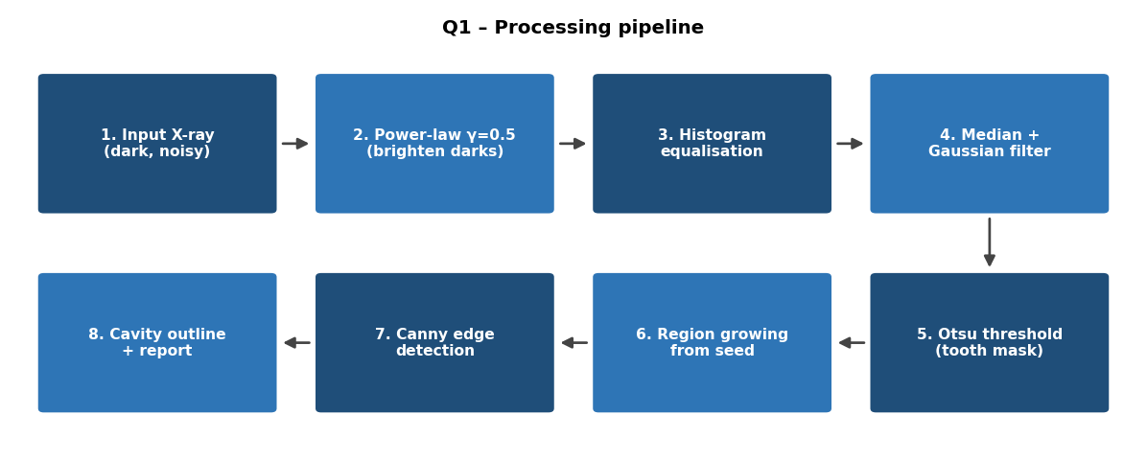
Figure 1.1 Q1 processing pipeline
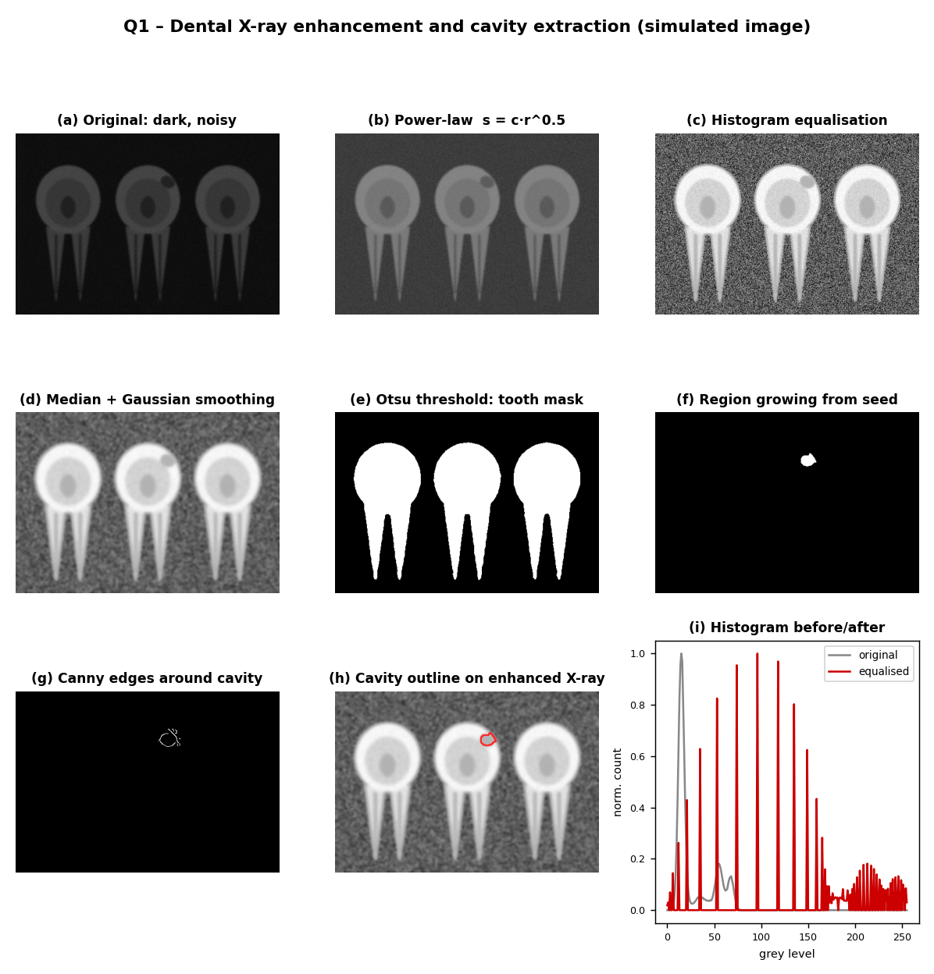
Figure 1.2 results at each stage (simulated radiograph with one cavity)

1.12 Evaluation
The result is compared with a dentist-drawn ground-truth mask using:
- Dice coefficient = 2 |A and B| / (|A| + |B|), where A is the predicted region and B the ground truth.
- IoU = |A and B| / |A or B|.
- Sensitivity = TP / (TP + FN), which shows how many real cavity pixels were found. This is the key clinical measure because a missed cavity is worse than a false alarm.
- Specificity = TN / (TN + FP).
- Contrast-to-noise ratio (CNR) of cavity versus surrounding enamel before and after enhancement, to prove that the visibility has improved.
A reasonable target is Dice above 0.7 and sensitivity above 0.85 on early lesions, with the final decision always left to the dentist.

1.14 Limitations and Possible Improvements
- Metal fillings cause streaks and saturation that the simple pipeline cannot remove; they should be masked out first.
- Overlapping teeth can create dark regions that resemble cavities. A dentist review or a learning-based classifier is needed to separate them.
- Deep-learning segmentation (for example U-Net) can be added later, with this pipeline used as a pre-processing and labelling aid.

1.15 Conclusion
The dental X-ray is first brightened with a power-law transformation, then contrast-enhanced with CLAHE, then denoised with a small median (and optionally bilateral) filter that keeps cavity boundaries sharp. The suspected cavity is extracted by an Otsu plus adaptive threshold followed by region growing, cleaned with morphology and outlined by the Canny detector. Each technique was selected against alternatives for a specific reason: gamma for tunable brightening, CLAHE for local contrast without noise explosion, median for edge-preserving noise removal, region growing for connected compact regions, and Canny for thin continuous outlines.

Question 2: Night-Time Vehicle Number Plate Region Extraction

2.1 Understanding of the Scenario
A traffic police department uses CCTV cameras at a toll gate. At night the camera must capture moving vehicles under poor and highly uneven lighting. The task of this stage is not to read the characters but to locate and extract the number-plate region so that an optical character recognition (OCR) stage can read it later. The output of our pipeline is therefore a tightly cropped, binarised plate image in which the characters are white (or black) on a clean background, plus the coordinates of the plate rectangle in the original frame.
The night-time toll-gate scene has a very large dynamic range. Most of the frame is nearly black, while headlights, reflective bumpers and the plate itself (which is retro-reflective) are close to saturation. The sensor gain is raised to compensate for darkness, which brings strong noise. The vehicle moves while the shutter is open, so the characters are smeared along the direction of motion.

2.2 Key Issues Identified
No. | Issue | Effect on plate extraction | Technique used
1 | Very low brightness | Plate characters not distinguishable from background | Log / power-law transformation
2 | Headlight glare (saturated bright blobs) | Histogram dominated by saturated pixels; false edges around lamps; plate washed out | Clipped (limited) histogram processing, histogram specification, homomorphic correction
3 | Sensor noise from high gain | Noise creates spurious edges | Median filter, then Gaussian smoothing
4 | Motion blur | Character strokes lose sharpness; edges become wide ramps | Laplacian sharpening, unsharp masking, optional Wiener deblurring
5 | Plate must be found in a cluttered scene | Grille, bumper, lamps and text on vehicle give many edges | Edge detection, line detection, edge linking, geometric filtering
6 | Characters must be separated from plate | OCR needs a clean binary image | Otsu and adaptive thresholding on the cropped plate

2.3 Complete Processing Pipeline
- Convert the frame to grey scale and select a region of interest (lower-central part of the vehicle).
- Enhance dark regions with grey-level transformations (log or gamma).
- Apply histogram processing (equalization with a clip limit, or histogram specification) while capping the influence of glare.
- Reduce noise with a median filter followed by light Gaussian smoothing.
- Restore edges with Laplacian sharpening or unsharp masking (and Wiener deblurring if the blur is strong).
- Detect edges (Sobel or Canny), emphasising vertical edges.
- Detect lines (line-detection masks, Hough transform) and link broken edges.
- Find rectangular candidates and filter them by size, aspect ratio and edge density.
- Crop the best candidate and apply thresholding to separate characters from the plate background.
- Output the plate image and its bounding box to the OCR stage.

2.4 Step 1: Grey Conversion and Region of Interest
Colour does not help to locate a plate at night because the camera is often in infrared or low-light mode. The frame is converted to grey scale using Y = 0.299 R + 0.587 G + 0.114 B. A region of interest is chosen: for a fixed toll-gate camera, plates always appear within a known band of the image, so the upper part (sky, roof) and the extreme sides are ignored. Reducing the area lowers both the amount of computation and the number of false candidates.

2.5 Step 2: Grey-Level Transformations for Dark Regions
The image histogram at night is bimodal in an unhelpful way: a huge peak near 0 and a small peak near 255 (glare). The dark region contains the vehicle body and, in many cases, parts of the plate.
Log transformation. s = c log(1 + r). It expands the darkest levels strongly. With c = 255 / log(256) = 45.99, an input of 5 becomes 45.99 x log(6) = 82 and an input of 20 becomes 45.99 x log(21) = 140. So pixels that were nearly invisible (5 to 20 out of 255) now occupy the middle of the range.
Power-law transformation. s = 255 (r / 255)^gamma. For night frames, gamma between 0.3 and 0.6 is used for the dark parts. For example, with gamma = 0.4 an input of 20 becomes 255 x (20 / 255)^0.4 = 255 x 0.359 = 92.
Problem with applying one curve to the whole frame. Brightening the full image also brightens the glare, which is already saturated. The glare area becomes a larger white blob and its halo covers the plate. To control this, a piecewise (two-segment) transformation is applied: the dark region is expanded using gamma < 1 up to a knee point (about r = 120), and above the knee the curve is flattened or slightly compressed so that bright pixels do not grow further. Pixels above about 240 are treated as saturated and are excluded when statistics are computed for the next step.
Method | Helps dark regions | Controls glare | Decision
Log | Strongly | No (it boosts everything) | Used for extremely dark frames only
Gamma < 1 | Yes, tunable | No by itself | Used as the base transform
Piecewise curve with flat upper segment | Yes | Yes | Selected: gamma below the knee, flat above
Homomorphic filtering | Yes | Yes (reduces illumination component) | Added when glare is wide-spread
Homomorphic filtering (glare control). An image is modelled as f(x, y) = i(x, y) r(x, y), where i is illumination (slowly varying, includes glare) and r is reflectance (details, characters). Taking the logarithm gives ln f = ln i + ln r, a sum. A high-pass-like filter that attenuates low frequencies (gamma_L about 0.5) and slightly boosts high frequencies (gamma_H about 1.5 to 2.0) is applied in the Fourier domain, and the exponential is taken afterwards. The result reduces the smooth halo of the headlights and strengthens the plate characters.

2.6 Step 3: Histogram Processing
After the grey-level transformation, the histogram is processed to spread contrast.

2.6.1 Histogram equalization and its glare problem
Global histogram equalization computes s_k = 255 x CDF(r_k). With a big saturated peak at 255 and a big dark peak near 0, the CDF jumps quickly in the dark region, and the mapping spreads dark pixels, but the saturated pixels still map to 255 and the mid-levels (where the plate characters are) get only a small share of the output range. Global HE is therefore not enough.

2.6.2 Contrast-limited adaptive equalization (CLAHE)
CLAHE equalises small tiles (for example 8 x 8) and clips each tile histogram at a limit before computing the CDF. The clipped excess is redistributed to all bins. This does two useful things for night scenes: the plate, which is a small local region, gets its own mapping so that character strokes are stretched; and the clip limit (about 2 to 4) prevents the noise in the dark background from being amplified into visible grain.

2.6.3 Histogram specification (matching)
If the system has a reference histogram from well-exposed plate images, the frame can be matched to it. The procedure is: equalise the input (s = T(r)), equalise the reference (v = G(z)), and map r to z = G^{-1}(T(r)). This lets us define a target histogram with a thin tail at the bright end, so glare cannot take over the output range. Specification is more controlled than plain HE and is useful when a fixed camera always sees the same kind of scene.

2.7 Step 4: Smoothing Filters
High-gain night sensors produce Gaussian-like noise plus bright and dark impulses (hot pixels). The two filters are applied in this order:
- Median filter (3 x 3). The median replaces each pixel by the middle value of its neighbourhood. It removes impulse noise completely without blurring the stroke edges. For the window 12, 14, 255, 13, 15, 14, 12, 13, 14 the sorted values are 12, 12, 13, 13, 14, 14, 14, 15, 255, giving 14. The outlier 255 disappears. A mean filter would return 40.2 and spread the outlier.
- Gaussian filter (3 x 3 or 5 x 5, sigma about 1). The kernel (1/16) [1 2 1; 2 4 2; 1 2 1] reduces remaining Gaussian noise with a smooth fall-off and no ringing.
The reason for median first is that Gaussian smoothing spreads an impulse into its neighbours, after which the median can no longer remove it. Smoothing is kept light because the next step restores edges; over-smoothing in this step would force over-sharpening later, which brings noise back.

2.8 Step 5: Sharpening Filters to Restore Character Edges
Motion blur and smoothing turn sharp stroke edges into gradual ramps. Sharpening uses derivatives to restore them.

2.8.1 Laplacian sharpening
The Laplacian is a second-derivative operator. The common 4-neighbour kernel is [0 1 0; 1 -4 1; 0 1 0]. Because its centre coefficient is negative, the sharpened image is g = f - laplacian(f).
Worked example on a vertical step edge with dark side 20 and bright side 100:
- Pixel on the dark side next to the edge: up 20, down 20, left 20, right 100, centre 20. Laplacian = (20 + 20 + 20 + 100) - 4 x 20 = 80. Sharpened = 20 - 80 = -60, clipped to 0.
- Pixel on the bright side next to the edge: up 100, down 100, left 20, right 100, centre 100. Laplacian = (100 + 100 + 20 + 100) - 400 = -80. Sharpened = 100 + 80 = 180.
The contrast across the edge grows from 80 to 180 (after clipping the undershoot), so the stroke edge is steeper. The drawback is that the Laplacian also amplifies noise, which is why noise reduction came before it.

2.8.2 Unsharp masking and high-boost filtering
g(x, y) = f(x, y) + k [f(x, y) - f_blur(x, y)], where f_blur is a Gaussian-blurred copy. With k = 1 this is unsharp masking and with k > 1 it is high-boost filtering. Example: f = 100, f_blur = 80, k = 1.5 gives g = 100 + 1.5 x 20 = 130. Unsharp masking amplifies only the detail layer (f minus blur) and does so with a controllable strength k; it is gentler with noise than the pure Laplacian because the blur inside the formula has already low-passed the detail.

2.9 Step 6: Edge Detection
A number plate is a rectangle with many closely spaced strokes, so it has a very high density of vertical edges. This property distinguishes it from other parts of the vehicle.
- Sobel operator: Gx = [-1 0 1; -2 0 2; -1 0 1] detects vertical edges (horizontal intensity change) and Gy detects horizontal edges. The magnitude is sqrt(Gx^2 + Gy^2). Taking only Gx emphasises the plate's character strokes and ignores the long horizontal lines of the bumper.
- Canny operator: Gaussian smoothing, gradient computation, non-maximum suppression and hysteresis thresholding give thin and continuous edges. Thresholds are set at T_low about 50 and T_high about 150.
The plate edge map is obtained by running Sobel Gx for localisation of the dense vertical-edge band and Canny for the exact rectangular border. The reason is that Sobel is fast and gives a density map, while Canny gives accurate thin contours.

2.10 Step 7: Line Detection and Edge Linking

2.10.1 Line detection
Line-detection masks (3 x 3) respond most strongly to one-pixel-wide lines in a particular direction:
Direction | Mask
Horizontal | [-1 -1 -1; 2 2 2; -1 -1 -1]
Vertical | [-1 2 -1; -1 2 -1; -1 2 -1]
+45 degrees | [-1 -1 2; -1 2 -1; 2 -1 -1]
-45 degrees | [2 -1 -1; -1 2 -1; -1 -1 2]
The plate rectangle has two long horizontal lines (top and bottom) and two short vertical lines (left and right). The horizontal and vertical masks are therefore the relevant ones. For longer and more reliable detection the Hough transform is used. A line is written in polar form as rho = x cos(theta) + y sin(theta). Each edge pixel votes for all (rho, theta) pairs of lines passing through it, and peaks in the accumulator correspond to lines. Example: the points (1, 1), (2, 2) and (3, 3) all give rho = 0 at theta = 135 degrees, so they all vote for the same cell and a peak of 3 appears. The probabilistic Hough transform (which returns line segments) is preferred because it is faster and handles broken lines.

2.11 Step 8: Locating the Rectangular Plate
The closed and linked edge map produces many connected components. Each one is converted to a minimum bounding rectangle and checked against geometric rules:
Rule | Typical acceptance range | Reason
Aspect ratio (width / height) | about 2 to 5.5 | Plates are wide rectangles (single-line format about 4 to 5; two-line format about 1.5 to 2)
Area | Between a minimum and maximum fraction of the frame | Rejects tiny noise blobs and large vehicle parts
Edge density inside the box | High | Characters create many short edges
Mean brightness contrast between box and neighbours | Plate brighter or darker than surroundings | Plates are reflective
Rotation angle | Within about plus or minus 15 degrees | Camera is fixed and looks along the lane
The candidate that satisfies the rules with the highest edge density is selected. The rectangle is cropped from the enhanced (not the binary) image with a small margin of a few pixels.

2.12 Step 9: Thresholding to Separate Characters from the Plate
The cropped plate is small and contains only two main classes: characters and plate background. Its histogram is therefore close to bimodal, which is ideal for Otsu's method, which finds T that maximises the between-class variance w0 w1 (mu0 - mu1)^2.
However, residual glare can create a brightness gradient across the plate (one side brighter), and then one global threshold fails. In that case adaptive thresholding is used: T(x, y) = Gaussian-weighted mean of an 11 x 11 neighbourhood minus a constant C (about 5). Sauvola thresholding, T = m [1 + k (s / R - 1)] with m the local mean and s the local standard deviation, is a stronger alternative for uneven lighting.
Method | Works when | Fails when
Global (Otsu) | Even illumination, bimodal histogram | Shadow or glare gradient across the plate
Adaptive mean/Gaussian | Uneven illumination | Large uniform regions (noise appears)
Sauvola | Uneven illumination and low contrast | Slightly slower
Decision. Otsu is tried first (it is parameter free); if the plate's left and right halves give very different thresholds, adaptive or Sauvola thresholding is used. The final image is inverted if needed so that characters are white on black, and small components smaller than about 0.5 percent of the plate area are removed. Vertical projection profiles (column sums of the binary image) are then used to find gaps between characters, preparing the OCR stage.

2.13 Python Implementation
lg = (255/np.log(1+255) * np.log1p(raw.astype(np.float32))).astype(np.uint8)
cl = cv2.createCLAHE(2.0,(8,8)).apply(lg)
med = cv2.medianBlur(cl,5)
un = cv2.addWeighted(med,1.8,cv2.GaussianBlur(med,(0,0),2),-0.8,0)
ed = cv2.Canny(un,60,160)
lines = cv2.HoughLinesP(ed,1,np.pi/180,40,minLineLength=60,maxLineGap=8)
linked = cv2.morphologyEx(ed,cv2.MORPH_CLOSE,cv2.getStructuringElement(cv2.MORPH_RECT,(25,5)))
# keep contours with 2.2<w/h<6 and highest edge density -> plate box (x,y,w,h)
_,bw = cv2.threshold(crop,0,255,cv2.THRESH_BINARY_INV+cv2.THRESH_OTSU)
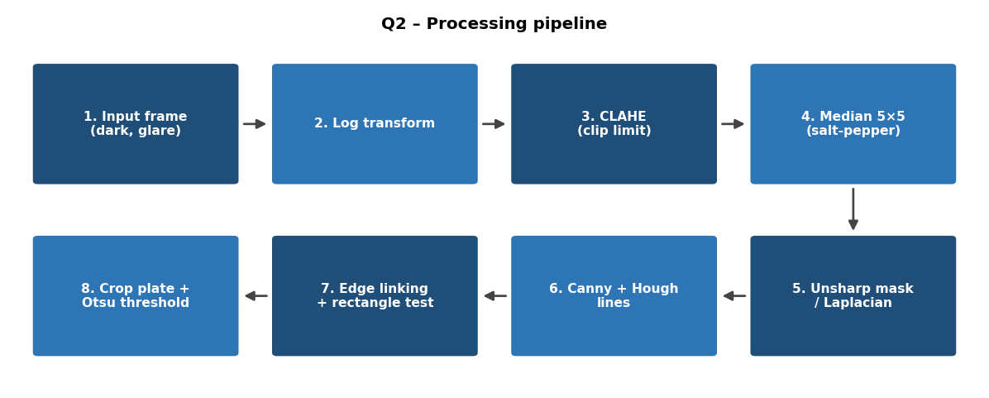
Figure 2.1 Q2 processing pipeline
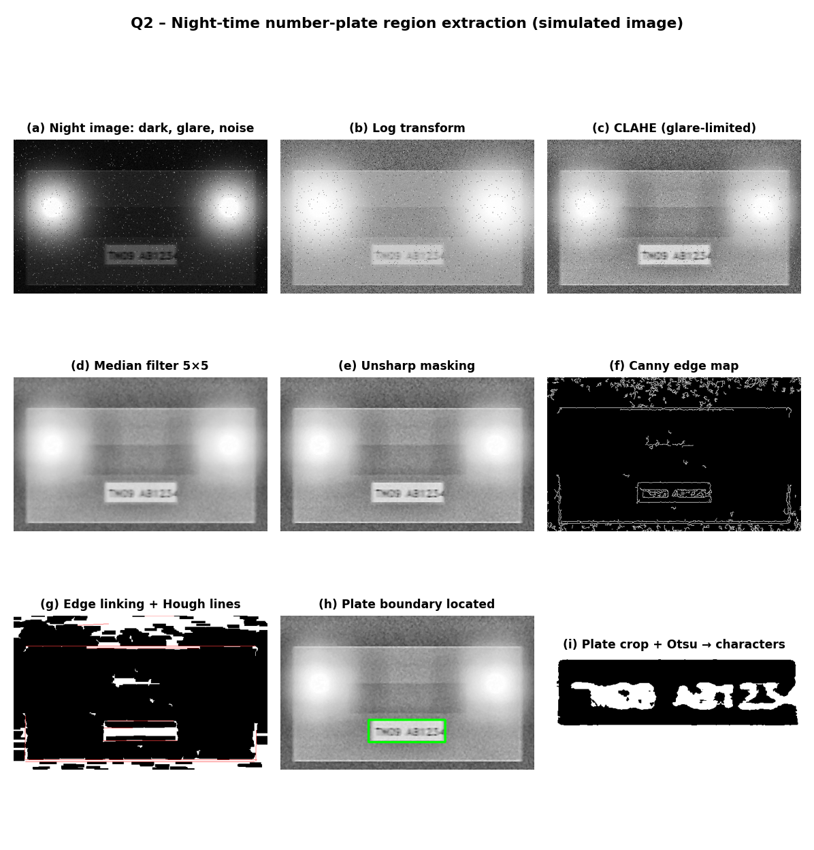
Figure 2.2 Q2 results at each stage (simulated night image)

2.14 Evaluation
- Plate detection rate = plates correctly located / total plates. A detection counts when the intersection-over-union of the detected box and the ground-truth box exceeds 0.5.
- False positive rate = non-plate boxes accepted / total frames.
- Character separability = Otsu between-class variance of the plate crop before and after enhancement.
- Processing time per frame, which should be well under 100 ms for real-time toll processing.
- OCR accuracy of the following stage as the final indirect measure.

2.15 Limitations and Improvements
- Strong glare directly over the plate cannot be restored; multi-exposure capture or an infrared illuminator with a polarising filter is better.
- Dirty, bent or decorated plates break the rectangle assumption; a classifier on candidate regions (for example HOG features with SVM) can reduce false detections.
- Motion blur parameters differ per vehicle, so a faster shutter and a fixed trigger position are recommended in addition to software deblurring.
- A deep detector (such as a single-shot detector trained on night plates) can replace the edge-based localisation while the enhancement steps above remain useful as pre-processing.

2.16 Conclusion
The night-time plate extraction pipeline starts by lifting dark regions with a piecewise gamma curve that caps glare, then applies contrast-limited histogram equalization. A median filter followed by Gaussian smoothing removes sensor noise and unsharp masking (or Laplacian sharpening) restores blurred stroke edges. Sobel and Canny edges, Hough line detection and edge linking identify the dense rectangular band of the plate, which is chosen using aspect-ratio, area and edge-density rules. Finally Otsu or adaptive thresholding separates the characters from the plate background. Every step either increases the signal (enhancement, sharpening) or removes interference (glare control, noise filtering, geometric filtering), and the order ensures that each stage receives input cleaned by the previous one.

Question 3: Textile Fabric Defect Detection Using Frequency-Domain Processing

3.1 Understanding of the Scenario
A textile mill inspects rolls of woven fabric with a line-scan camera. The camera captures one thin line of pixels at a time while the fabric moves, and the lines are stacked to form a long two-dimensional image. A woven fabric is a highly regular structure: warp (vertical) and weft (horizontal) threads cross at fixed spacing, so the image is a repeating tile. A defect (hole, broken thread, oil stain or knot) is a local break in this regularity.
This scenario is a natural fit for the frequency domain because of one fact: a repeating pattern in space appears as a small set of sharp peaks in the Fourier spectrum, while a local, non-repeating defect appears as weak, spread-out energy. If the peaks are removed, the weave disappears and what is left is mostly the defects and noise.
Two disturbances must also be handled: periodic noise from the machine lighting (for example 50 Hz flicker of lamps, which produces horizontal bands when the fabric moves) and uneven illumination across the roll width (the middle is brighter than the edges).

3.2 Key Issues Identified
No. | Issue | Why it matters | Technique used
1 | Regular weave texture | Produces strong, busy background that hides small defects | Notch / band-reject filtering at weave frequencies
2 | Periodic noise from lighting | Adds stripes that can be mistaken for defects (or hide them) | Notch filtering at the noise frequency
3 | Uneven illumination across the width | A fixed threshold would mark the dark edges as defective | Histogram processing (CLAHE) and homomorphic filtering
4 | Random sensor noise | Gives isolated false detections | Low-pass (Gaussian) filtering of the residual
5 | Defects have different brightness (dark stains, bright holes, texture changes) | One-sided thresholds miss some | Two-sided threshold on the residual
6 | Defects must be reported with shape and position | Needed for grading and marking the roll | Thresholding, morphology, boundary detection

3.3 Overall Pipeline and Order of Operations
- Acquire line-scan data and assemble overlapping image blocks (for example 512 x 512 pixels).
- Correct uneven illumination (homomorphic filtering or background division, then histogram equalization).
- Compute the 2D Fourier transform and display the log spectrum.
- Detect the peaks produced by the weave and by the lighting.
- Build a notch / band-reject filter that removes those peaks (and their harmonics) while keeping everything else.
- Apply a mild Gaussian low-pass filter to remove random noise.
- Inverse transform to get the residual image that contains the defects.
- Apply histogram stretching to the residual.
- Threshold the residual (two-sided) and clean the mask with morphology.
- Detect and outline the boundaries of the defective regions, then report their features.

3.4 Frequency-Domain Fundamentals

3.4.1 The 2D discrete Fourier transform
For an M x N image f(x, y) the DFT is
F(u, v) = sum over x = 0 to M-1 and y = 0 to N-1 of f(x, y) exp[-j 2 pi (ux / M + vy / N)]
and the inverse is f(x, y) = (1 / MN) sum over u, v of F(u, v) exp[+j 2 pi (ux / M + vy / N)]. Multiplying f(x, y) by (-1)^(x + y) before the transform moves the zero frequency (DC term) to the centre (M/2, N/2) so that the spectrum is easy to view and filters can be defined around the centre.
The magnitude spectrum is displayed as log(1 + |F(u, v)|), because the DC term and the peaks are many orders larger than the rest.

3.4.2 Filtering in the frequency domain
By the convolution theorem, spatial convolution with a kernel h(x, y) equals multiplication of spectra:
G(u, v) = H(u, v) F(u, v), and g(x, y) = real part of the inverse DFT of G(u, v).
To avoid wrap-around error (the DFT treats the image as periodic), the image and the filter are zero-padded to P x Q = 2M x 2N before the transform.

3.4.3 What a weave looks like in the spectrum
Suppose the fabric image is 512 pixels wide and the weft threads repeat every 8 pixels. The fundamental frequency in the u direction is 512 / 8 = 64 cycles per image width, so there are bright peaks at u = plus or minus 64 from the centre. The harmonics (because the pattern is not a pure sine) appear at plus or minus 128, plus or minus 192 and so on. If the warp repeats every 6 pixels in a 512-pixel height, peaks appear at v = plus or minus 85 and its harmonics. Cross terms between the two give a regular lattice of peaks. A defect does not repeat, so its energy is spread across all frequencies and sits at the base of the spectrum. Periodic lighting noise creates peaks of its own: for a flicker producing a band every 20 lines, a pair of isolated peaks appear on the vertical frequency axis at v = plus or minus 512 / 20, about 26.

3.5 Frequency-Domain Filters
Let D(u, v) be the distance from the centre of the (shifted) spectrum and D0 the cut-off.
Filter | Transfer function | Behaviour
Ideal low-pass | H = 1 if D <= D0, else 0 | Sharp cut; causes ringing in the image
Butterworth low-pass (order n) | H = 1 / [1 + (D / D0)^(2n)] | Smooth transition, little ringing for n = 1 to 2
Gaussian low-pass | H = exp[-D^2 / (2 D0^2)] | No ringing; smooth blur
High-pass | H_hp = 1 - H_lp | Keeps edges and fine detail; removes smooth shading
Band-reject (Gaussian) | H = 1 - exp{-[(D^2 - D0^2) / (D W)]^2} | Removes a ring of frequencies of width W
Notch reject (Butterworth) | H = product over k of 1 / [1 + (D0^2 / (D_k D_-k))^n] | Removes small neighbourhoods around chosen peaks and their symmetric partners
Notch reject (Gaussian) | H = 1 - exp[-D_k^2 / (2 D0^2)] for each peak | Smooth, no ringing
Worked values. For a Gaussian low-pass with D0 = 30: at D = 30, H = exp(-0.5) = 0.607; at D = 60, H = exp(-2) = 0.135; at D = 90, H = exp(-4.5) = 0.011. For a Butterworth low-pass of order 2 with D0 = 30: at D = 30, H = 0.5; at D = 60, H = 1 / (1 + 16) = 0.059. For a Gaussian notch with D0 = 5 pixels centred on a peak: at the peak itself, H = 0; at a distance of 5 pixels, H = 1 - exp(-0.5) = 0.393; at 15 pixels, H = 1 - exp(-4.5) = 0.989. The filter therefore deletes the peak and leaves everything farther than about 15 pixels untouched. Notch filters always come in symmetric pairs, because the spectrum of a real image is symmetric: a notch at (u0, v0) requires one at (-u0, -v0).

3.6 Step 1: Correcting Uneven Illumination (Histogram Processing)
The illumination across the fabric width varies slowly, which means that it is a low-frequency component. If it is left in place, the residual image will have a bright band in the middle and dark edges, and a global threshold would fail. Two complementary methods are used.
Homomorphic filtering. The image is modelled as f = i x r (illumination times reflectance). Taking the logarithm gives ln f = ln i + ln r. A high-pass filter of the form H = (gamma_H - gamma_L)[1 - exp(-c D^2 / D0^2)] + gamma_L, with gamma_L about 0.5, gamma_H about 1.5 and D0 about 10, reduces the slowly varying illumination term and keeps the reflectance (weave and defects). The exponential brings the image back.
Histogram processing. After the illumination term is reduced, contrast-limited adaptive histogram equalization (CLAHE) with a tile size that is a multiple of the weave period (for example 64 x 64) equalises each block so that any remaining brightness difference between the centre and the edges is evened out. Plain global equalization is not suitable because it cannot treat different areas of the roll differently. Another simple alternative is to divide the image by a heavily blurred copy (Gaussian sigma about 50): g = f / blur(f) x mean(f), which flattens the shading.
Worked example. If the centre of the roll has a mean of 180 and the edge has a mean of 90, a defect in the centre with value 150 and one at the edge with value 60 are both 30 below their local mean, but a global threshold at 100 would flag the whole edge and miss the central defect. After dividing by the local mean (180 and 90) and multiplying by the global mean of 135, the central background is 135 and the defect is 112.5; the edge background is 135 and the defect is 90. Both defects now stand out by the same relative amount and the background is uniform.

3.7 Step 2: Spectrum Analysis and Peak Detection
The corrected image is zero-padded, multiplied by (-1)^(x + y), and transformed. The log magnitude spectrum is formed. The peaks produced by the weave and the lighting are located automatically:
- Smooth the log spectrum with a small Gaussian to avoid single-pixel maxima.
- Suppress the area around the centre (the DC and very low frequencies carry the average brightness and should not be removed).
- Select local maxima that exceed the median of the spectrum by a number of standard deviations (for example 4 sigma) in a 7 x 7 neighbourhood.
- Keep the list of peak coordinates (u_k, v_k) and add the symmetric partner (-u_k, -v_k) of each.
Automatic selection is needed because the spacing of the weave changes with fabric type and with tension, so a fixed set of coordinates would not work for all rolls. For a stable production run the list can be learned once from a defect-free sample and reused for all blocks.

3.8 Step 3: Suppressing Periodic Noise and the Weave
A Gaussian notch-reject filter is built as the product of notches around all detected peaks:
H_NR(u, v) = product over k of [1 - exp(-D_k(u, v)^2 / (2 D0^2))],
where D_k is the distance from (u, v) to the k-th peak. The width D0 (about 3 to 8 pixels in the spectrum) is a compromise: if D0 is too small, some of the periodic energy remains and faint weave patterns survive; if D0 is too large, a part of the defect spectrum near the peak is also removed and small defects become weaker.
The weave removal and the lighting-noise removal use exactly the same mechanism. The only difference is where the peaks are: weave peaks form a regular lattice (and are usually the strongest), while lighting peaks lie on the axis along the direction of motion. When the peaks of the lighting noise form a ring-like or band-like pattern (because the frequency drifts), a band-reject filter is more suitable than isolated notches.
Why not a low-pass or a high-pass for the weave? The weave frequency is mid-range: it is higher than the illumination but comparable to the frequency content of small defects. A low-pass filter that removes the weave would also remove small holes and knots (which have similar spatial frequencies); a high-pass would keep the weave. Only a notch filter can remove the weave while keeping the rest of the mid-frequency band.

3.9 Step 4: Low-Pass Smoothing of the Residual
After the weave and lighting peaks are deleted, the spectrum still contains random sensor noise at high frequencies. A Gaussian low-pass with D0 about 0.25 of the half-image size (for example D0 = 60 for a 512 x 512 block) is multiplied with the notch filter, giving a single combined filter H = H_NR x H_LP. Gaussian is preferred over ideal and Butterworth filters because it causes no ringing: ringing rings would appear as faint ripples around holes and could be mistaken for additional defects. Mild smoothing also fills the small gaps in a thin broken thread so that it forms a continuous region.
The inverse transform is calculated, the real part taken, the (-1)^(x + y) factor re-applied, and the padded area cropped away. The result is the residual image: a nearly flat grey image in which defects appear as brighter or darker patches.

3.10 Step 5: Histogram Stretching of the Residual
The residual has a narrow histogram around a mean mu with standard deviation sigma. The values are linearly stretched so that the range mu - 4 sigma to mu + 4 sigma fills 0 to 255. This brings out weak defects (for example a faint oil stain) before the threshold. Equalization is avoided here because it would amplify the background noise, which makes up most of the pixels.

3.11 Step 6: Thresholding
In the residual, the background has a roughly Gaussian distribution around mu, while defects are outliers on either side. Therefore a two-sided threshold is used:
g(x, y) = 1 if |f(x, y) - mu| > k sigma, otherwise 0, with k about 3 to 4.
Mu and sigma are estimated robustly using the median and the median absolute deviation (sigma = 1.4826 x MAD) so that the defects themselves do not influence the estimate. This choice has a clear statistical meaning: with k = 3, about 0.27 percent of defect-free pixels exceed the threshold (about 700 false pixels in a 512 x 512 block), and these isolated pixels are removed afterwards by morphology; with k = 4 only about 0.006 percent exceed it.
Otsu's method is also tested, but the histogram is dominated by the background, so the two classes (defect and background) are very unequal in size, which makes the variance criterion unreliable. The statistical threshold is therefore the preferred method. When illumination correction is imperfect, an adaptive (local) threshold can be used instead of the global one.
Post-processing. The binary mask is opened with a 3 x 3 element to delete isolated pixels, closed with a 5 x 5 element to join fragments (for example the two ends of a broken thread), and components smaller than a minimum area (for example 30 pixels) are removed.

3.12 Step 7: Boundary Detection and Outlining
The defect regions are outlined using several tools:
- Morphological boundary: beta(A) = A - (A eroded by B), where B is a 3 x 3 structuring element. This gives the one-pixel-wide boundary of each region.
- Edge detection: Canny (or Sobel) applied to the mask or the stretched residual gives thin outlines. Applied to the mask it yields exactly one outline per defect.
- Contour tracing and chain codes: an algorithm (such as Moore boundary tracing) follows each boundary and records it as a list of direction codes. This is a compact representation from which perimeter, area, bounding box, aspect ratio and orientation can be computed.
The contours are drawn over the original image so that the inspector or the marking machine sees them in context. Simple features then give a first classification: a hole is small, nearly round and bright; an oil stain is large, irregular and dark; a broken thread is long and thin (high aspect ratio, aligned with the warp or weft); a knot is small and compact with a high local contrast.
Defect | Typical residual appearance | Feature used to classify
Hole | Bright, compact | Area small, circularity high, mean above background
Oil stain | Dark, irregular, larger | Area large, circularity low, mean below background
Broken thread | Thin line along warp or weft | Aspect ratio above about 5
Knot | Small bright or dark dot | Area very small, high local contrast

3.13 Why Frequency-Domain Processing Is Preferred Here
The main reason is that the weave is a global, periodic structure and the disturbance (lighting) is also periodic, so both are described by a handful of Fourier coefficients. A spatial filter that is large enough to average out a weave of 8-pixel period must be much bigger than the period, and it blurs every defect smaller than that. In the frequency domain the same result is obtained by zeroing a few coefficients, with minimal damage to the defects. The weakness of the frequency domain is that it is global, so it does not say where a defect is; this is why the inverse transform is used and the localisation steps (thresholding and boundary detection) are carried out in the spatial domain on the residual image. The best system therefore combines both domains, using each where it is strong.

3.14 Python Implementation
Key Code:
F = np.fft.fftshift(np.fft.fft2(raw.astype(np.float32)))
pk = peak_local_max(mag_without_dc, min_distance=6, threshold_abs=0.12*mag.max())
notch = np.ones((N,N))
for (py,px) in pk: notch *= 1-np.exp(-((x-px)**2+(y-py)**2)/(2*3.5**2))
filt = np.real(np.fft.ifft2(np.fft.ifftshift(F*notch)))
illum = np.real(np.fft.ifft2(np.fft.ifftshift(np.fft.fftshift(np.fft.fft2(filt))*G))) # Gaussian LPF
flat = filt/np.maximum(illum,1)*128 ; st = percentile_stretch(flat)
dev = np.abs(st-np.median(st)) ; _,bw = cv2.threshold(dev8,0,255,cv2.THRESH_OTSU)
cnts,_ = cv2.findContours(bw,cv2.RETR_EXTERNAL,cv2.CHAIN_APPROX_SIMPLE)

Images
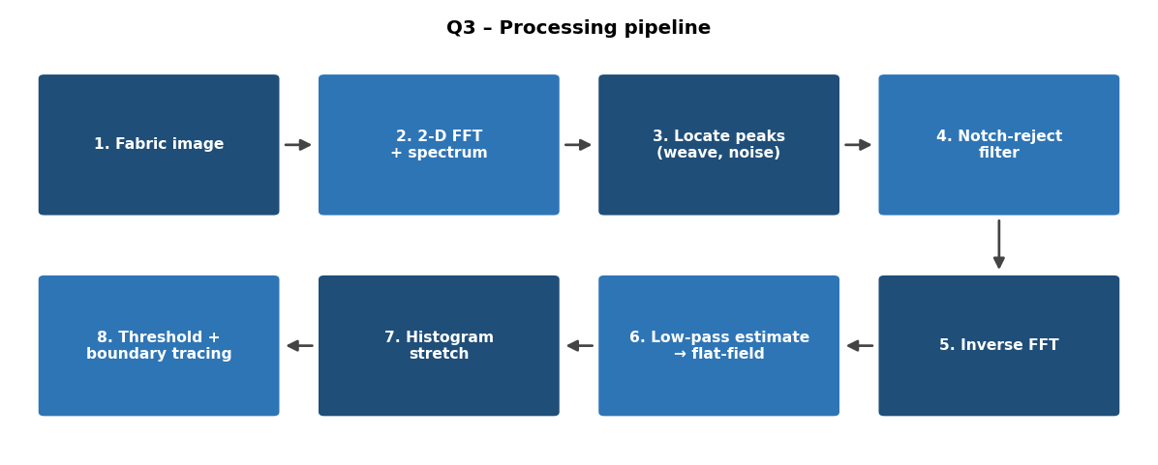
Figure 3.1 Q3 processing pipeline
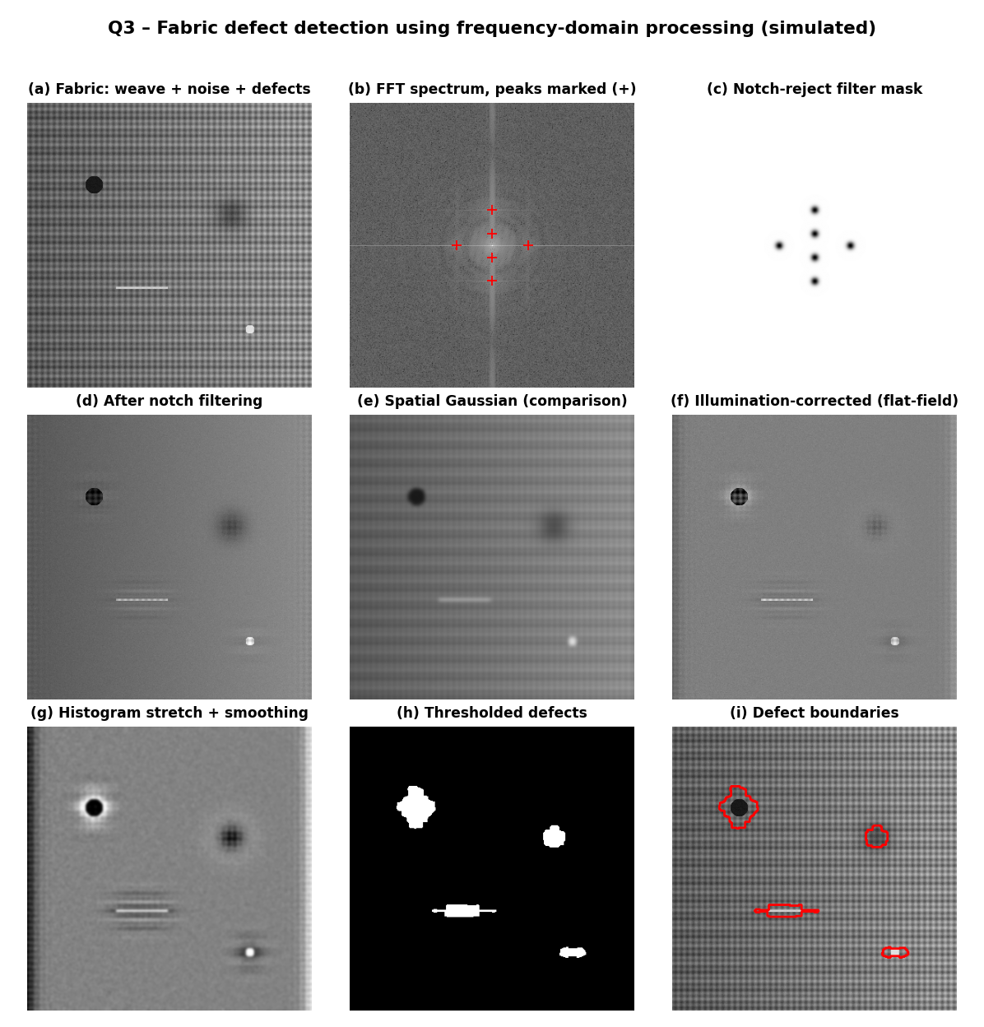
Figure 3.2 Q3 results at each stage (simulated fabric with four defects)

3.15 Evaluation
- Detection rate (recall) = defects found / defects present, and false alarm rate = false regions per square metre of fabric.
- Localisation quality using the intersection-over-union between detected region and the inspector's mark.
- Background suppression measured as the ratio of weave-peak energy before and after the notch filter (a reduction of 20 dB or more is a good target).
- Contrast-to-noise ratio of defect versus background in the residual compared with the original.
- Speed. For a 512 x 512 block the FFT, filter and inverse FFT take a few milliseconds on a CPU, which is adequate for a line rate of several kilohertz when blocks are processed in a pipeline.

3.16 Limitations and Improvements
- Fabrics with printed patterns or changing weave (for example jacquard) do not have a fixed set of peaks. A Gabor filter bank or a wavelet-based method can replace the notch filter.
- Very large defects (for example a big oil stain) have a lot of low-frequency energy and can be partly removed by the illumination correction; the homomorphic cut-off should therefore be chosen below the size of expected defects.
- Block edges can create artefacts, so blocks are processed with overlap and windowed with a Hann function before the FFT.
- Peaks drift when the fabric stretches. The peak list is re-estimated for each block or tracked over time.

3.17 Conclusion
For woven fabric, the sequence is: flatten the illumination using homomorphic filtering and CLAHE, move to the Fourier domain, detect the spectral peaks caused by the weave and the lighting, delete them with Gaussian notch-reject filters, smooth with a Gaussian low-pass filter, return to the spatial domain and stretch the residual. A statistical two-sided threshold then isolates holes, stains, broken threads and knots, and morphological and contour-based boundary detection outline them. Frequency-domain processing is preferred because the weave and the lighting noise are periodic and are represented by a few coefficients that can be removed precisely and efficiently, whereas any spatial filter big enough to do the same would blur or erase the defects that we are trying to find.

Question 4: Blood Cell Segmentation in Microscopic Images

4.1 Understanding of the Scenario
A pathology laboratory uses an automated microscope to photograph stained blood smears. The system must count red blood cells (RBCs, also called erythrocytes) and white blood cells (WBCs, also called leukocytes). RBC counts help to diagnose anaemia and polycythaemia; WBC counts help to diagnose infection and leukaemia. Manual counting is slow and varies between observers, so an accurate automatic count is valuable.
In a stained smear (for example Giemsa or Leishman stain), RBCs appear as pinkish discs with a pale centre, WBCs appear as larger cells with a dark purple nucleus, and the background is almost white or light pink. The task is to convert such an image into a set of separate cell regions, one region per cell, with accurate boundaries.
The images supplied have these difficulties: uneven staining (the colour and brightness differ across the slide), low contrast between pale cells and the background, cells that touch or overlap (so that a simple threshold gives one merged blob), and small dust particles on the slide that look like tiny dark spots.

4.2 Key Issues Identified
No. | Issue | Consequence | Technique used
1 | Uneven staining and illumination | A global threshold labels part of the background as cells (or part of the cells as background) | Colour-channel selection, CLAHE, adaptive thresholding
2 | Poor contrast between cells and background | Cell boundary is weak | Contrast stretching, histogram equalization
3 | Dust particles and stain speckles | Counted as cells, which gives false counts | Median filter, area filtering
4 | Touching and overlapping cells | Two or three cells counted as one | Region growing from distance-transform seeds (marker-based), split and merge
5 | Pale cell centre (central pallor) | Hole inside the RBC mask | Hole filling, morphological closing
6 | Need individual outlines for counting and measurement | Cell features (area, shape) require boundaries | Edge detection, contour tracing, boundary extraction

4.3 Processing Pipeline
- Read the colour image and select the channel that gives the best cell-to-background contrast (green channel or saturation).
- Enhance contrast with contrast stretching and histogram equalization (CLAHE for uneven staining).
- Remove noise and dust with a median filter (and an area filter later).
- Segment cells from background using global (Otsu) or adaptive thresholding.
- Clean the mask with morphology and fill the central-pallor holes.
- Separate touching cells with region-based segmentation (region growing from markers, or region splitting and merging).
- Detect edges and extract boundaries of each separated cell.
- Label, count, measure and classify the cells; draw outlines on the original image.

4.4 Step 1: Channel Selection
A stained smear is a colour image, but a single grey channel is easier to process. The green channel is chosen because haemoglobin in RBCs and the stain in WBC nuclei strongly absorb green light, so cells are dark in the green channel while the background (which hardly absorbs) is bright. The red channel has poor contrast (RBCs transmit red light), and the blue channel is noisy. An equivalent alternative is the saturation channel of HSV, in which stained cells have high saturation and the background has low saturation; this is more robust against brightness variation. The decision is to use the green channel by default and the saturation channel when the lamp intensity varies a lot between fields.

4.5 Step 2: Contrast Enhancement and Histogram Processing

4.5.1 Contrast stretching
The grey levels of a poorly contrasted smear occupy only a part of the range. Linear contrast stretching maps the minimum r_min and the maximum r_max to 0 and 255:
s = 255 (r - r_min) / (r_max - r_min).
Worked example: if the green channel has r_min = 90 (cell) and r_max = 190 (background), a pixel of 140 maps to 255 x 50 / 100 = 127.5, a cell pixel of 100 maps to 25.5, and a background pixel of 180 maps to 229.5. The difference between a typical cell and a typical background pixel, which was about 70 grey levels, becomes about 178 grey levels. To avoid the effect of a few extreme pixels (dust, glare), the 1st and 99th percentiles are used instead of the true minimum and maximum.

4.5.2 Histogram equalization and CLAHE
Histogram equalization remaps the intensities with the cumulative distribution s_k = 255 x CDF(r_k), spreading the most common grey levels. In a smear the background occupies most of the pixels, so global equalization uses most of the output range for background variations and little for the cell-to-background difference; it can also amplify the stain unevenness. CLAHE divides the image into tiles (for example 8 x 8), limits the histogram at a clip limit of about 2 and equalises each tile. Since staining varies slowly over the slide, a tile-based mapping equalises the stain between regions; the clip limit avoids noise amplification in empty background areas.

4.5.3 Histogram specification
Images from different slides or stain batches differ in colour. Matching each image histogram to the histogram of a well-stained reference slide (histogram specification) makes later threshold values consistent from slide to slide. This is optional but helps to keep the same parameters for the whole laboratory.
Decision. Contrast stretching using percentiles, followed by CLAHE. This combination handles both global low contrast and local staining variation.

4.6 Step 3: Spatial Filtering of Noise and Dust
Dust particles are small (about 2 to 8 pixels across) compared with a cell (about 60 to 100 pixels across at typical magnification). Sensor noise is fine-grained. The filter must remove features smaller than about 8 pixels but must not move the edges of cells.
Filter | Effect on dust and noise | Effect on cell boundary | Decision
Mean (box) filter | Spreads dust into a grey halo instead of removing it | Blurs the boundary | Rejected
Gaussian filter | Reduces noise, does not remove dust | Blurs the boundary slightly | Useful for light pre-smoothing
Median filter (5 x 5 or 7 x 7) | Removes dust smaller than half the window | Preserves step edges | Selected
Bilateral filter | Smooths inside cells while keeping edges | Excellent | Alternative when the interior is textured

4.7 Step 4: Thresholding
The cells are darker than the background in the green channel, so the cell mask is g(x, y) = 1 if f(x, y) < T and 0 otherwise.

4.7.1 Global thresholding (Otsu)
Otsu's method chooses T that maximises the between-class variance sigma_B^2(T) = w0 w1 (mu0 - mu1)^2. Worked example with an 8-level histogram of 84 pixels with counts 10, 20, 10, 2, 2, 10, 20, 10 for levels 0 to 7:
T | Class 0 (levels up to T): n, mean | Class 1: n, mean | sigma_B^2
2 | 40, 1.00 | 44, 5.77 | 0.476 x 0.524 x 22.8 = 5.68
3 | 42, 1.10 | 42, 5.90 | 0.5 x 0.5 x 23.1 = 5.78
4 | 44, 1.23 | 40, 6.00 | 0.524 x 0.476 x 22.8 = 5.68
The maximum is at T = 3, which lies in the valley between the two peaks, as expected. If the smear is evenly stained, the histogram is bimodal (cells and background) and Otsu gives a good result without any parameter.

4.7.2 Adaptive thresholding
With uneven staining, a single T cannot be correct everywhere: in a lightly stained area the cells are brighter than the threshold of a heavily stained area. The adaptive threshold uses a local window: T(x, y) = m(x, y) - C, where m is the Gaussian-weighted mean in a window larger than a cell (for example 101 x 101) and C a small constant (about 5 to 10). A pixel is a cell when it is darker than its neighbourhood by more than C. The window must be larger than a cell, otherwise the interior of a large cell would be classified as background.
Criterion | Global (Otsu) | Adaptive
Parameters | None | Window size, constant C
Even staining | Excellent | Good
Uneven staining | Poor | Good
Empty background regions | Correct | May create noise (needs area filtering)
Speed | Very fast | Fast
Decision. After CLAHE, the uneven staining is mostly corrected and Otsu is applied; if the stain unevenness is still visible (for example the threshold differs between the left and right halves of the image), the adaptive threshold is used. A practical combination is to take the logical AND of the Otsu result and a lenient adaptive result, which removes background noise from the adaptive result while keeping the correct local boundary.

4.7.3 Mask clean-up
Opening with a 3 x 3 or 5 x 5 disc removes isolated pixels and thin bridges. Components smaller than about 100 pixels (dust, platelets, debris) are deleted. Holes inside cells (the pale centre of an RBC) are filled using hole filling (flood fill of the background from the border, then inversion), because otherwise an RBC appears as a ring.

4.8 Step 5: Separating Touching Cells by Region-Based Segmentation
Thresholding is a pixel-wise operation that ignores spatial arrangement, so two touching cells become one connected region. Region-based methods use the spatial neighbourhood and a homogeneity criterion to partition the foreground.

4.8.1 Region growing with marker seeds
Region growing starts from seed pixels and adds neighbouring pixels that satisfy a similarity criterion. The quality of the result depends on good seeds. In a binary mask there is no intensity information, so the distance transform is used to find seeds: each foreground pixel receives the distance to the nearest background pixel, and the maxima of this map lie at the centres of the cells.
Worked example. Two circular cells of radius 20 pixels have their centres 30 pixels apart, so they overlap and appear as one blob. At each centre the distance transform is 20. At the neck (the narrowest point of the blob) the half-width is sqrt(20^2 - 15^2) = sqrt(175) = 13.2, so the distance transform at the neck is about 13.2. The map has two peaks of 20 separated by a saddle of 13.2. Using an h-maxima transform (suppress peaks whose height above the saddle is less than h = 3), two seeds remain, one in each cell. A single blob without a neck has only one peak and gets one seed.
Growing procedure:
- Label each seed as a separate region.
- Place all neighbours of all seeds in a priority queue ordered by the dissimilarity (here the inverted distance value, or the gradient magnitude when the intensity image is used).
- Repeatedly remove the best pixel, assign it to the neighbouring region, and add its unlabelled neighbours to the queue.
- Stop when the queue is empty. Where two regions meet, a boundary line is drawn; this is exactly where the neck lies.
This competitive growing procedure is the principle of the watershed algorithm, which is the usual implementation of marker-controlled region growing. Using markers solves the main weakness of watershed (over-segmentation caused by noise minima), because only the selected seeds are allowed to grow.

4.8.2 Region splitting and merging
An alternative is the quadtree-based split-and-merge method. The image is first split recursively into quadrants until each quadrant satisfies a homogeneity predicate Q (for example the standard deviation of intensity below a limit, or all pixels of the same mask value). Adjacent regions that together satisfy Q are then merged. Splitting separates a blob at the neck because the quadrants around the neck contain mixed background and foreground and are split further, whereas the quadrants in the cell interior are homogeneous and are merged back into one region per cell. Split and merge does not need seeds and is useful when the cells are not circular, but its boundaries follow the quadtree grid unless a final refinement step is added, so it is used as a secondary method.

4.8.3 Choice
Marker-based region growing is selected as the main method because blood cells are close to convex and round, so the distance transform gives reliable seeds, and the competitive growth produces smooth boundaries at the contact line. Split and merge is kept for clusters whose shapes are irregular (for example crenated cells or large WBC clumps).
Approach | Needs seeds | Handles round touching cells | Boundary quality | Weakness
Thresholding only | No | No | Good outer boundary only | Merged blobs
Marker-based region growing | Yes (automatic from the distance map) | Very well | Smooth | h parameter for seed selection
Split and merge | No | Moderately | Blocky | Grid artefacts

4.9 Step 6: Edge Detection and Boundary Extraction
Once each cell has its own label, boundaries are extracted for display, measurement and counting.
- Edge detection. The Canny detector (Gaussian smoothing, gradient, non-maximum suppression, double threshold, hysteresis) is applied to the enhanced grey image to obtain thin, continuous edges, which are used to refine the outlines obtained from the mask. Sobel gradient magnitude can be used where a fast approximation is enough. The gradient is high at the membrane of the cell, where the intensity changes from dark to bright.
- Boundary detection. For each labelled region A, the boundary is beta(A) = A - (A eroded by B) with a 3 x 3 structuring element B. The contour is traced with a boundary-following algorithm and stored as a chain code. From it, area, perimeter, centroid and bounding box are computed.
- Optional circular Hough transform. Because the cells are round, circles can be fitted to the outlines of touching cells to estimate the position and radius of cells whose boundaries are partly hidden.

4.10 Step 7: Counting and Classification
Each labelled region is a cell. Features are computed to classify it. Circularity = 4 pi A / P^2 equals 1 for a circle and is smaller for irregular shapes. WBCs are distinguished from RBCs by a larger area (typically 1.5 to 3 times the RBC area) and by the presence of a dark nucleus in the colour image (very low green value in the interior).
Cell type | Area (relative) | Interior | Circularity
RBC | 1.0 | Pale centre, uniform pink | High, above 0.8
WBC | 1.5 to 3.0 | Dark purple nucleus | Moderate to high
Platelet or dust | Below 0.2 | Small dark dot | Variable (removed by area filter)

4.11 Python Implementation
Key code:
g = raw[:,:,1]
eq = cv2.createCLAHE(3.0,(4,4)).apply(g)
med = cv2.medianBlur(eq,5)
_,ot = cv2.threshold(med,0,255,cv2.THRESH_BINARY_INV+cv2.THRESH_OTSU)
cl = cv2.morphologyEx(ot,cv2.MORPH_OPEN,cv2.getStructuringElement(cv2.MORPH_ELLIPSE,(9,9)))
cl = ndi.binary_fill_holes(cl>0).astype(np.uint8)*255
dist = cv2.distanceTransform(cl,cv2.DIST_L2,5)
pk = peak_local_max(cv2.GaussianBlur(dist,(0,0),2),min_distance=13,threshold_abs=9,labels=cl>0)
lab = watershed(-dist, markers, mask=cl>0) ; edges = find_boundaries(lab,mode='outer')

Images
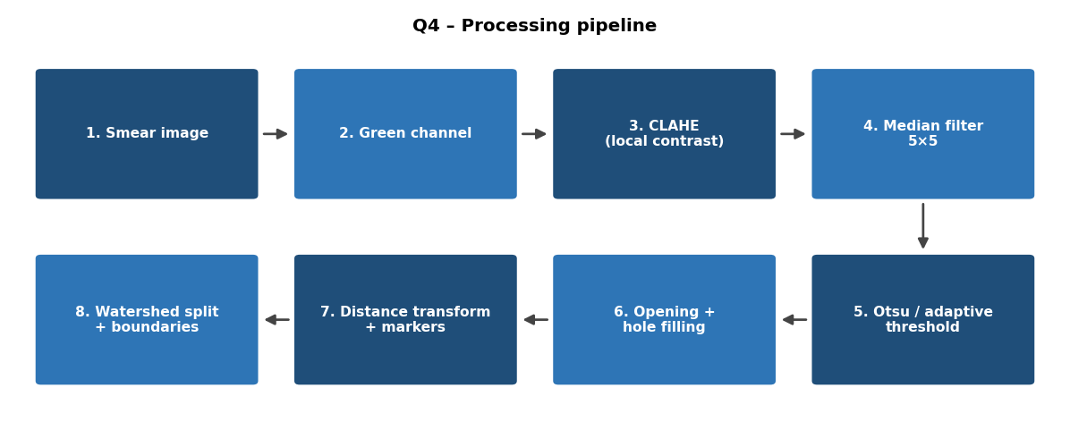
Figure 4.1 Q4 processing pipeline
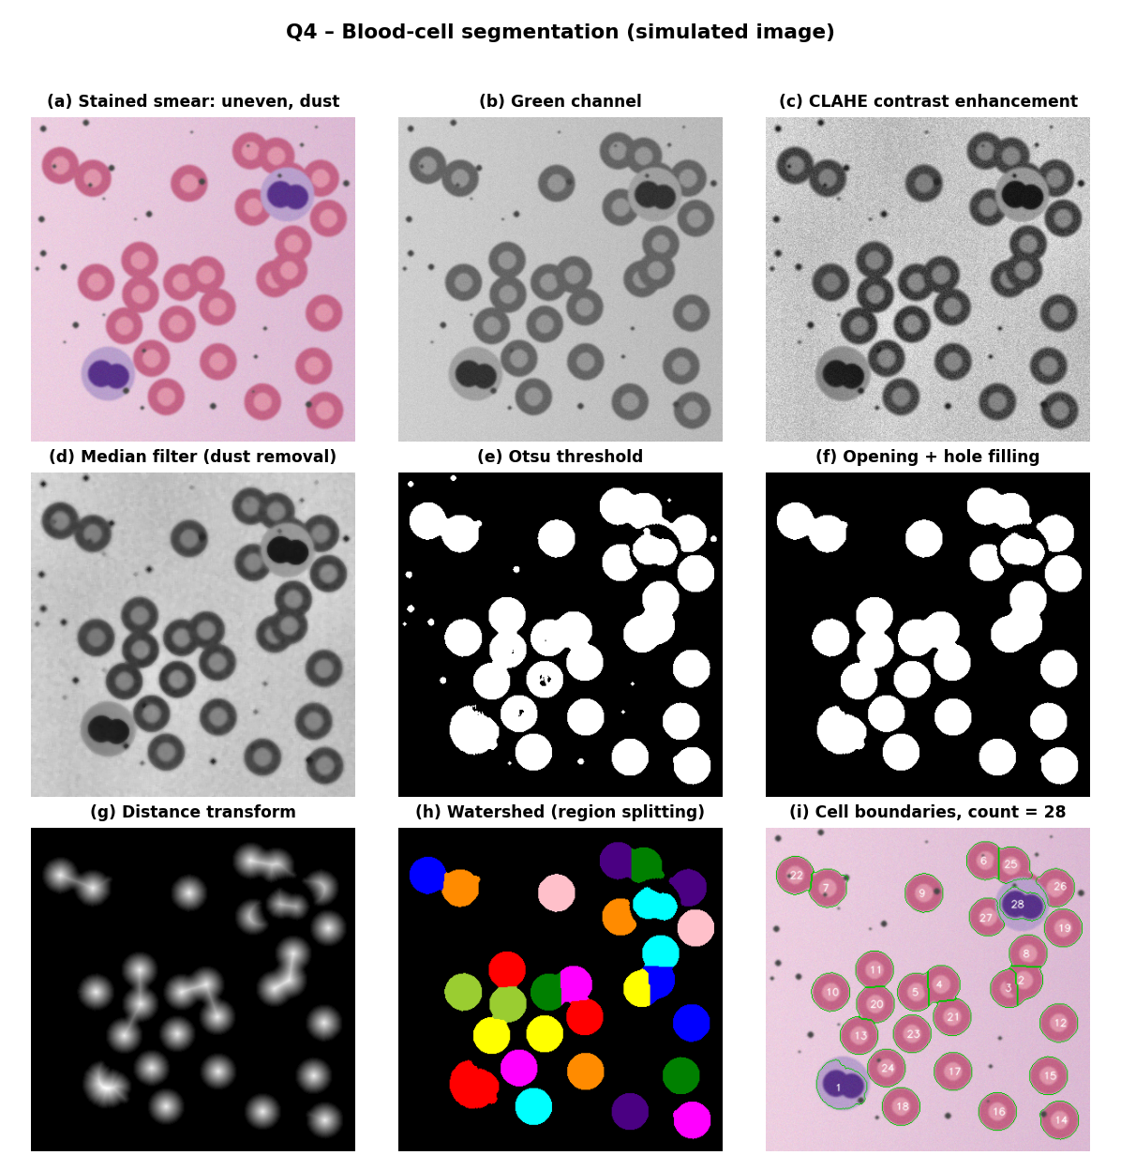
Figure 4.2 Q4 results at each stage (simulated blood smear)

4.12 Evaluation
- Count accuracy: compare the automatic RBC and WBC counts with those of an expert (or of a haemocytometer). The relative error should be below about 5 percent.
- Detection precision, recall and F1 per cell, with a match defined by intersection-over-union above 0.5.
- Segmentation quality: Dice coefficient and boundary distance between predicted and expert-drawn outlines for a set of annotated cells.
- Split and merge errors: the number of under-segmented (merged) and over-segmented (split) cells, which show how well the touching cells were separated.
- Robustness: the pipeline is tested on slides with different stain batches and lighting.

4.13 Conclusion
The blood-smear pipeline selects the green channel, improves contrast through stretching and CLAHE, removes dust and noise with a median filter, separates cells from background with Otsu or adaptive thresholding, and cleans and fills the mask. Touching cells are split by region growing from distance-transform seeds (the competitive growth principle of watershed), with split and merge as a back-up. Canny edge detection and morphological boundary tracing then give an outline for each individual cell, which supports accurate counting, measurement and classification of RBCs and WBCs. Each technique was chosen for a particular defect of the images: CLAHE for uneven staining, median for dust, adaptive thresholding for local variation, and marker-based region growing for touching cells.

Question 5: Text Extraction from Degraded Historical Documents

5.1 Understanding of the Scenario
A state archive is digitising old handwritten manuscripts. The scanned pages are degraded in several ways at once: the paper has yellowed, ink from the reverse side shows through (bleed-through), there are stains, some strokes have faded to a light grey-brown, and the lighting during scanning is uneven. The archive wants the text regions separated cleanly from everything else before a handwriting recognition (HTR) system is applied, and wants the lines and words to be identified.
The central difficulty is that the text is not simply darker than the background. A pen stroke, a faded stroke, a bleed-through stroke and a stain are all darker than clean paper, but only the first two are text. A method that is only based on darkness fails; the method must exploit differences in strength, local contrast and shape. Handwriting also differs from print: strokes have variable thickness, lines are slightly curved and slanted, and spacing between words is irregular.

5.2 Key Issues Identified
No. | Issue | Effect | Technique used
1 | Yellowed paper | Background is not white; some colour channels lose contrast | Channel selection and background normalisation
2 | Faded strokes | Ink is close to paper in brightness | Contrast stretching, power-law transformation, CLAHE
3 | Bleed-through | Faint mirrored text of the other page appears as text | Gamma darkening, local thresholding, bilateral filtering
4 | Stains and blotches | Large dark areas become false text | Background estimation, local thresholding, area filtering
5 | Uneven lighting | Page is brighter in the middle than near the edges | Background division (flat-field correction)
6 | Noise and speckles (paper fibres, scanner noise) | Spurious small components | Median filter
7 | Need for text lines and word regions | HTR works on lines or words | Edge detection, projection profiles, morphological linking, boundary detection

5.3 Complete Processing Pipeline
- Colour scan to grey scale (choice of channel).
- Background normalisation to remove uneven lighting and the yellow tint.
- Grey-level transformations (power law and negative) to strengthen faded ink and weaken bleed-through.
- Histogram processing (contrast stretching and CLAHE).
- Smoothing (median, bilateral) to remove stains, speckles and noise.
- Sharpening (unsharp masking) to strengthen pen strokes.
- Thresholding: compare global (Otsu) with local (Niblack or Sauvola), and apply the better one.
- Edge detection and boundary detection; morphological linking.
- Identify text lines (projection profile) and word regions (connected components with horizontal dilation).
- Output the clean binary image and the line and word bounding boxes to the HTR stage.

5.4 Step 1: Grey-Scale Conversion
The usual luminance conversion is Y = 0.299 R + 0.587 G + 0.114 B. For yellowed paper the channel choice matters. Yellow paper absorbs blue light, so in the blue channel the paper becomes dark and its brightness approaches that of faded ink: the contrast is worst there. In the red channel the paper stays bright while brown or black ink is dark, so contrast is best. The red channel (or a weighted combination that gives the red channel more weight, or the first principal component of the RGB values) is therefore selected. This is a simple decision that increases the ink-to-paper difference before any processing starts.

5.5 Step 2: Background Normalisation (Flat-Field Correction)
The page brightness is the product of the paper reflectance, the stain and the lighting. A smooth estimate B(x, y) of this background is made by a large median filter (for example 51 x 51, larger than a stroke width and much smaller than the page), or by morphological closing with a large element (which removes thin dark strokes and leaves the background), followed by smoothing. The normalised image is
g(x, y) = 255 x f(x, y) / B(x, y), limited to a maximum of 255.
Worked example: in the page centre the paper has B = 220 and a faded stroke f = 160, giving g = 255 x 160 / 220 = 185. Near the edge the paper is darker, B = 150, and the same stroke has f = 109; g = 255 x 109 / 150 = 185. Both areas now give the same value for the same ink, and paper everywhere becomes 255. Uneven lighting and yellow tinting disappear in one step.

5.6 Step 3: Grey-Level Transformations
After normalisation, paper is at 255, true ink is anywhere from 0 (dark) to about 190 (faded), and bleed-through is typically at 210 to 240 because it is seen through the paper and is weaker than ink.
Contrast stretching. The useful range [r1, r2] is mapped to [0, 255]. If ink pixels lie in 20 to 190 and paper at 255, a linear stretch from 20 to 255 gives s = 255 (r - 20) / 235. A faded stroke at 190 maps to 184 and a dark one at 60 to 43, a bit more room between ink and paper.
Power-law transformation with gamma greater than 1. s = 255 (r / 255)^gamma. This curve compresses the bright levels, so that levels near 255 (paper and weak bleed-through) become more distinct from the darker ink levels. Worked example with gamma = 3, using normalised values:
Image negative. s = 255 - r makes text bright on a dark background. It is applied optionally when the later tools (connected components, morphological operations) assume bright foreground; it does not change the information.
Log transformation is not suitable for the main step because it expands dark values, which are the ink; it would not suppress bleed-through. It would help only for very dark, underexposed pages.

5.7 Step 4: Histogram Processing
The histogram of a manuscript page has a very tall peak at paper brightness and a small, spread-out tail for ink and stains. Global histogram equalization allocates most output levels to the paper peak and amplifies small paper-texture variations and stains, so it is not suitable. Two tools are used instead:
- Histogram stretching with percentiles: the 0.5th and 99.5th percentiles define the range that is mapped to 0 to 255, which ignores a few extreme pixels such as black scanner borders.
- CLAHE: tiles of about 64 x 64 pixels (a few characters wide) with a clip limit of about 2. It raises the local contrast of faded words without exaggerating noise in empty paper areas, because the histogram is clipped. A moderate clip limit is important; too high a value makes bleed-through as strong as the real text.
The order is stretch first and CLAHE second, as the stretch removes the dead range and gives CLAHE a better starting point. The thresholding that follows is local and therefore tolerates some residual unevenness.

5.8 Step 5: Smoothing Filters
The purpose is to remove speckle, fibres, small stains and scanner noise without damaging pen strokes, which are only 2 to 6 pixels wide.
Filter | Removes speckle | Preserves thin strokes | Remark | Decision
Mean filter | Spreads it | Blurs strokes, joins close letters | Not suitable | Rejected
Gaussian filter | Reduces noise | Slight blur | Useful with small sigma | Light use
Median filter (3 x 3) | Yes (isolated pixels, fibres) | Yes | Strokes wider than 2 pixels survive | Selected
Bilateral filter | Reduces noise and paper texture | Yes | Smooths bleed-through and stains while keeping strong edges | Selected (second stage)
Morphological opening / closing | Removes objects smaller than the element | Depends on the element | Good for stain and component clean-up | Used after thresholding
A 3 x 3 median filter applied to the window 250, 252, 90, 251, 249, 250, 251, 250, 252 (a speckle at 90) gives 250, and the speckle disappears; the mean would be 232. A thin vertical stroke 3 pixels wide is preserved, as the median of a window that is partly stroke and partly paper is determined by the majority. A bilateral filter weights each neighbour by both distance and intensity similarity: w = exp(-d^2 / 2 sigma_s^2) x exp(-(Delta I)^2 / 2 sigma_r^2). With sigma_r about 30, a neighbour that differs by 100 grey levels (paper versus ink) gets a weight of exp(-5.6), almost zero, so the stroke boundary is not blurred, while weak differences (bleed-through against paper, 20 to 40 levels) are averaged away.
Large stains are not removed by these filters. They are handled by the background estimate (low-frequency stains are included in B), the local threshold (which sees the stain as a locally dark region and compares pixels to the stain), and the area filter.

5.9 Step 6: Sharpening to Strengthen the Pen Strokes
After smoothing, strokes can look soft. Unsharp masking restores the edge: g = f + k (f - f_blur), with a Gaussian of sigma about 1 to 2 and k about 1 to 1.5. Worked example: a stroke edge pixel f = 120, blurred 150, k = 1.2 gives g = 120 + 1.2 x (120 - 150) = 84. The stroke becomes darker and the contrast against the paper increases from 130 to 171 (for paper at 255). The Laplacian sharpening g = f - laplacian(f) can also be used but it amplifies residual noise more; therefore unsharp masking is selected, with the median and bilateral filters before it so the noise has already been removed. Sharpening comes after smoothing because sharpening first would raise the noise and speckle that the smoothing step is intended to remove.

5.10 Step 7: Global versus Local Thresholding

5.10.1 Global thresholding (Otsu)
Otsu's method selects a single T for the whole page to maximise sigma_B^2 = w0 w1 (mu0 - mu1)^2. It requires no parameters and is excellent for a clean page with uniform paper and uniformly dark ink (bimodal histogram). In this scenario the histogram has many modes: dark ink, faded ink, stains of different strengths, bleed-through and paper. Otsu gives one compromise value that is too high for stained areas (the stain becomes text) or too low for faded strokes (they vanish). Uneven lighting shifts the whole mode structure across the page, so no single T is correct everywhere.

5.10.2 Local (adaptive) thresholding
Local methods compute T(x, y) from the mean m and standard deviation s in a window around each pixel (the window should cover a few characters, about 25 to 51 pixels).
- Niblack: T = m + k s, with k about -0.2. Works for text but produces noise in empty paper areas (s is very small, so T is just below m and noise passes).
- Sauvola: T = m [1 + k (s / R - 1)], with k about 0.2 to 0.5 and R = 128 (dynamic range of s). When s is small (empty paper or uniform stain), T drops far below m so that the noise is not marked as text. When s is large (near a stroke), T approaches m, which keeps the stroke.
- Adaptive Gaussian threshold: T = weighted local mean minus constant C. Simple, but it has the Niblack weakness in empty areas.
Worked comparison with k = 0.3 and R = 128:
Region | Local m | Local s | Sauvola T | Test pixel | Result
Clean paper, text nearby | 200 | 10 | 200 x [1 + 0.3 x (10/128 - 1)] = 145 | Faded ink at 110 | Text (110 < 145)
Same area | 200 | 10 | 145 | Bleed-through at 170 | Background (170 > 145)
Stain region | 120 | 30 | 120 x [1 + 0.3 x (30/128 - 1)] = 92 | Stain pixel at 110 | Background (110 > 92)
Stain region | 120 | 30 | 92 | Dark ink at 60 | Text (60 < 92)
A global Otsu threshold of, say, 140 would mark the stain pixel at 110 as text (false positive) and would give the same result as Sauvola for the other rows. The local threshold sees that 110 is only slightly darker than its surroundings (a stain) while 60 is much darker (ink).

5.10.3 Comparison and decision
Criterion | Global (Otsu) | Local (Sauvola)
Parameters | None | Window, k
Uneven lighting | Fails | Handles
Stains | Marks stains as text | Suppresses most stains
Faded strokes | Lost if T is low | Kept (compares to local background)
Bleed-through | Depends on T | Suppressed (weak local contrast)
Speed | Very fast | Fast (integral images)
Risk | Wrong for most of the page | Broken thick strokes if window too small
Decision: Sauvola local thresholding is applied because the page is a mixture of degradations that change over the page. Otsu is kept as a fast first estimate (for example to find the page margins). The window is set to about 3 character widths, so that it covers both text and background, and k is set to 0.3. After normalisation and CLAHE, an alternative with similar effect is to use Otsu on each tile, but Sauvola is simpler and uses the same local statistics.

5.10.4 Post-processing of the binary image
A median filter (3 x 3) on the binary image or a small opening removes isolated dots; connected components smaller than about 15 pixels or with an extreme aspect ratio and very large size (stain edges, page borders) are deleted; a 3 x 3 closing joins breaks in faded strokes.

5.11 Step 8: Edge Detection and Boundary Detection for Lines and Words

5.11.1 Edge detection
Sobel or Canny edges of the enhanced grey image describe stroke outlines: Gx = [-1 0 1; -2 0 2; -1 0 1], Gy = [-1 -2 -1; 0 0 0; 1 2 1]; the gradient magnitude is sqrt(Gx^2 + Gy^2). Canny (sigma about 1, hysteresis thresholds 30 and 90) gives thin and continuous outlines and rejects weak bleed-through edges due to the high threshold. The edge density map (number of edge pixels per window) is high where there is text and low in margins and on plain paper, so it provides a fast text-region detector that is independent of the grey level. Because handwriting contains many vertical and diagonal strokes, the density of Gx is a good indicator of a text line.

5.11.2 Text line detection
The horizontal projection profile of the binary image is P(y) = sum over x of b(x, y). Rows crossing text have a high sum and the gaps between lines have a very small sum. A simple example for 10 rows: P = 0, 14, 36, 41, 22, 3, 0, 18, 39, 35 gives two peaks (rows 1 to 4 and rows 7 to 9) with a valley at rows 5 to 6, so there are two lines, with the boundary placed at the minimum of the valley. For handwriting the lines are rarely perfectly horizontal; therefore the profile is smoothed with a Gaussian, the page is divided into vertical strips (for example 5 strips) and the profile of each strip is used to follow the line as it curves. If the page is skewed, the skew angle is first estimated by rotating the binary image and choosing the angle with the sharpest profile (the largest variance), or by the Hough transform on the edge map, and then corrected.

5.11.3 Word region detection
Inside each line, the vertical projection profile or a morphological method is used. The morphological method is: dilate the binary line image with a horizontal rectangular element whose width is slightly greater than the typical gap between letters in a word and smaller than the gap between words (for example 15 x 3 pixels for a letter gap of 5 and a word gap of 25). The letters of a word merge into one connected component. The run-length smoothing algorithm (RLSA) does the same thing: any run of background pixels shorter than a threshold between two foreground pixels is filled. Each connected component is then taken as a word region.

5.11.4 Boundary detection
For every component, the boundary beta(A) = A - (A eroded by B) is extracted and traced with a contour-following algorithm. The bounding rectangle of the contour is the word box, the union of the boxes in a line is the line box, and the coordinates are stored together with the cropped binary image (from the original binary image, not the dilated one, so letter shapes are not distorted). Boxes that are too small, too large or have unusual aspect ratios are discarded; boxes whose centres are close vertically are grouped into one line.

5.12 Python Implementation
Key Code:
gray = cv2.cvtColor(raw,cv2.COLOR_RGB2GRAY)
flat = np.clip(gray/np.maximum(cv2.medianBlur(gray,61),1)*210,0,255).astype(np.uint8)
enh = cv2.createCLAHE(2.5,(8,8)).apply(flat)
sm = cv2.GaussianBlur(cv2.medianBlur(enh,3),(0,0),1.0)
sh = cv2.addWeighted(sm,1.7,cv2.GaussianBlur(sm,(0,0),2),-0.7,0)
_,otsu = cv2.threshold(gray,0,255,cv2.THRESH_BINARY_INV+cv2.THRESH_OTSU)
adp = cv2.adaptiveThreshold(sh,255,cv2.ADAPTIVE_THRESH_GAUSSIAN_C,cv2.THRESH_BINARY_INV,41,22)
edges = cv2.Canny(cv2.GaussianBlur(clean,(0,0),1.5),50,150)
d = cv2.dilate(clean,cv2.getStructuringElement(cv2.MORPH_RECT,(70,3))) # lines

Images
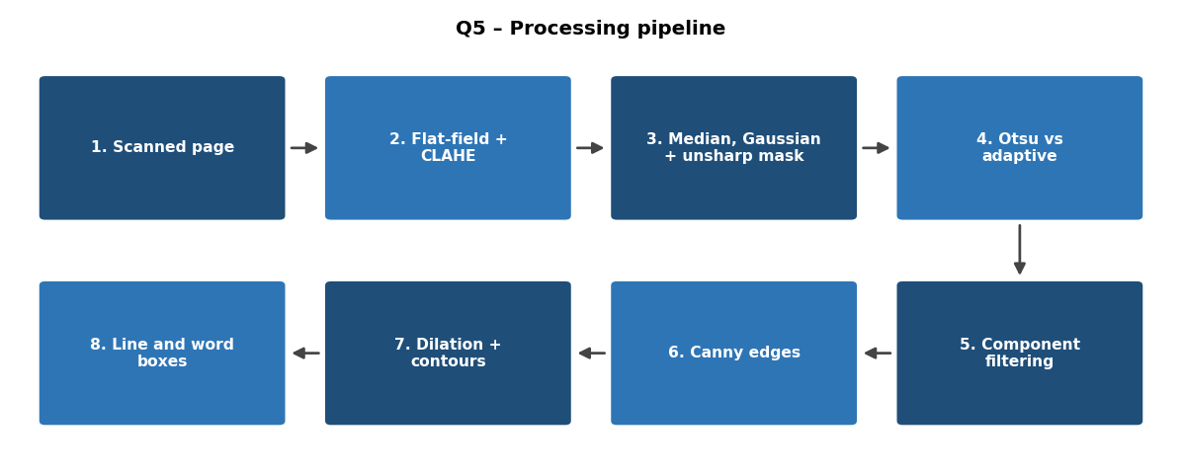
Figure 5.1 processing pipeline
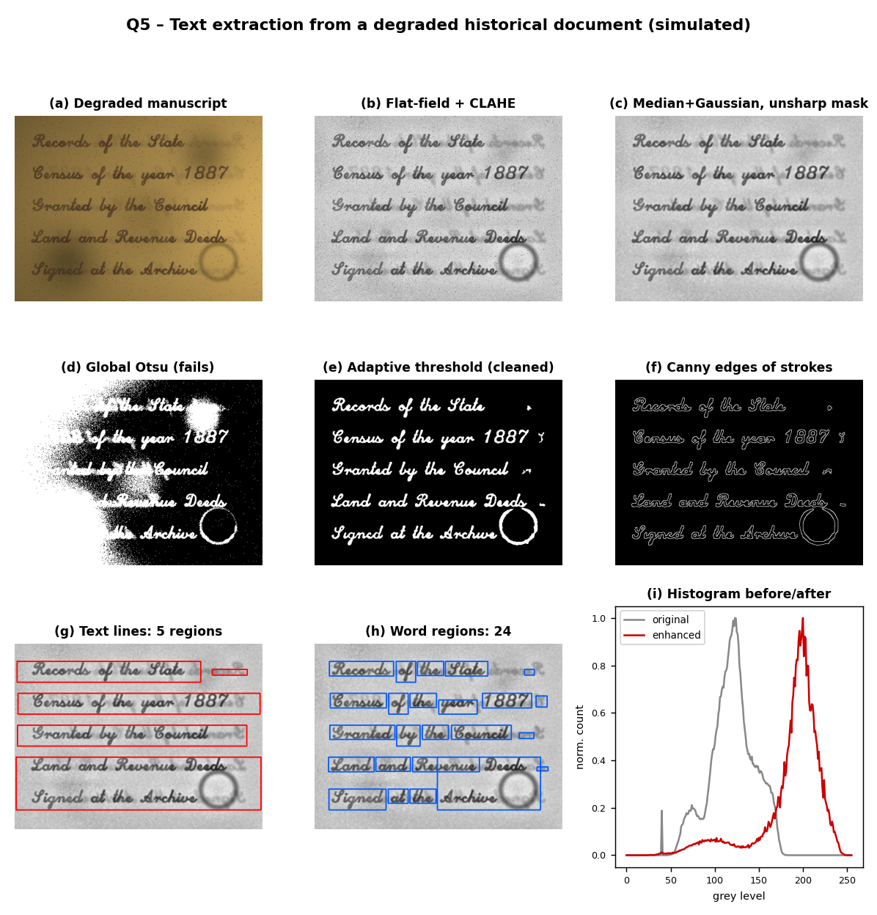
Figure 5.2 results at each stage (simulated degraded manuscript)

5.13 Evaluation
- Binarisation quality against a hand-made ground truth: F-measure, pseudo F-measure, PSNR and distance reciprocal distortion (DRD), the standard metrics of the document image binarisation competitions (DIBCO).
- Line and word detection: precision, recall and F1 of boxes at an intersection-over-union of 0.5.
- Downstream measure: the character error rate (CER) and word error rate (WER) of the handwriting recognition after the pre-processing, compared with the raw scan and with a simple Otsu baseline. This is the most meaningful test because it measures the purpose of the pipeline.
- Visual inspection by an archivist, as the archive requires faithful preservation of the writing.

5.14 Limitations and Improvements
- Very strong bleed-through (of equal darkness to the real ink) cannot be separated by thresholding. The recto and verso scans can be registered and used together (a two-sided method), or a trained network can be applied.
- Touching lines and overlapping ascenders and descenders make line separation by profiles ambiguous; seam carving or a path-finding method between the lines handles this.
- Parameters depend on scan resolution (usually 300 to 400 dpi); sizes should be expressed relative to the estimated stroke width.
- The binary image should be stored only as an additional product; the original scan remains the archival master.
- Deep learning binarisation and text-line detection can improve the results, but the classical pipeline gives interpretable and controllable results on small collections.

5.15 Conclusion
For degraded manuscripts, the pipeline selects the red channel, normalises the background to remove yellowing and uneven lighting, strengthens faded ink and weakens bleed-through with a gamma greater than 1, and improves local contrast with percentile stretching and CLAHE. Median and bilateral filters remove speckle and weak show-through texture while keeping the strokes, and unsharp masking sharpens the pen strokes. Local Sauvola thresholding is chosen over global Otsu because the page is affected by stains, fading and changing illumination that make a single threshold wrong in most of the page. Edge and boundary detection, projection profiles and horizontal dilation then provide the text lines and word regions, giving the handwriting recognition system a clean binary image and well-defined regions to work on.

